CLOUD AND IoT in Arduino
EXPERIMENT 6
SETUP for both experiments
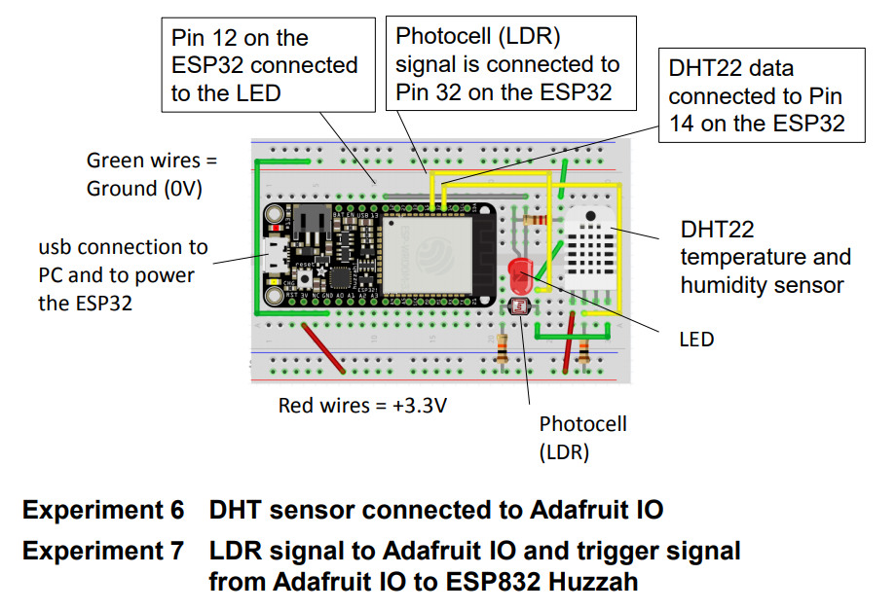
EXPERIMENT 6(successful results)
Comments removed since code is directly from examples and in the interest of space).
#include "config.h"
#include <Adafruit_Sensor.h>
#include <DHT.h>
#include <DHT_U.h>
#define DATA_PIN 14
DHT_Unified dht(DATA_PIN, DHT22);
AdafruitIO_Feed *temperature = io.feed("temperature");
AdafruitIO_Feed *humidity = io.feed("humidity");
void setup() {
Serial.begin(115200);
while(! Serial);
dht.begin();
Serial.print("Connecting to Adafruit IO");
io.connect();
while(io.status() < AIO_CONNECTED) {
Serial.print(".");
delay(500);
}
Serial.println();
Serial.println(io.statusText());
}
void loop() {
io.run();
sensors_event_t event;
dht.temperature().getEvent(&event);
float celsius = event.temperature;
float fahrenheit = (celsius * 1.8) + 32;
Serial.print("celsius: ");
Serial.print(celsius);
Serial.println("C");
Serial.print("fahrenheit: ");
Serial.print(fahrenheit);
Serial.println("F");
temperature->save(fahrenheit);
dht.humidity().getEvent(&event);
Serial.print("humidity: ");
Serial.print(event.relative_humidity);
Serial.println("%");
humidity->save(event.relative_humidity);
delay(5000);
}
Config.h File Code
#define IO_USERNAME "borrisroy" //io username
#define IO_KEY "aio_kVTJ62xeEAmRUhHrseKgqb8gvbpF" //io key
#define WIFI_SSID "Brookes WiFi" //wifi ssid
#define WIFI_PASS "HelloBrookes" //WiFi password
#include "AdafruitIO_WiFi.h"
#if defined(USE_AIRLIFT) || defined(ADAFRUIT_METRO_M4_AIRLIFT_LITE) || \
defined(ADAFRUIT_PYPORTAL)
#if !defined(SPIWIFI_SS) // if the wifi definition isnt in the board variant
#define SPIWIFI SPI
#define SPIWIFI_SS 10 // Chip select pin
#define NINA_ACK 9 // a.k.a BUSY or READY pin
#define NINA_RESETN 6 // Reset pin
#define NINA_GPIO0 -1 // Not connected
#endif
AdafruitIO_WiFi io(IO_USERNAME, IO_KEY, WIFI_SSID, WIFI_PASS, SPIWIFI_SS,
NINA_ACK, NINA_RESETN, NINA_GPIO0, &SPIWIFI);
#else
AdafruitIO_WiFi io(IO_USERNAME, IO_KEY, WIFI_SSID, WIFI_PASS);
#endif

HUMIDITY AND TEMPERATURE DASHBOARD
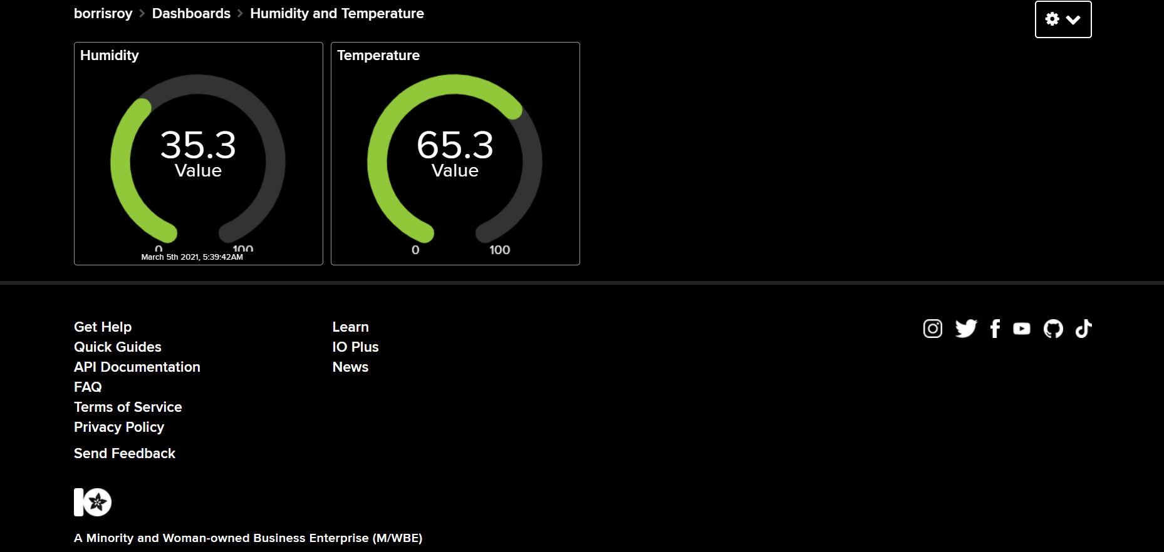

HUMIDTY FEED
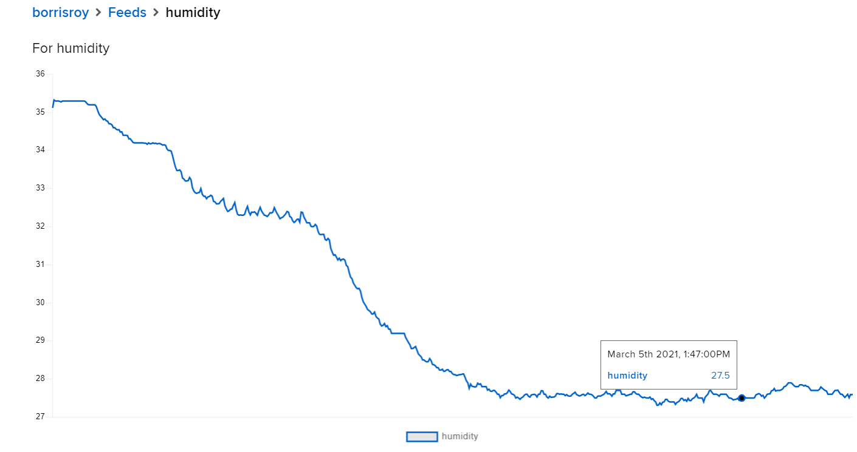

TEMPERATURE FEED
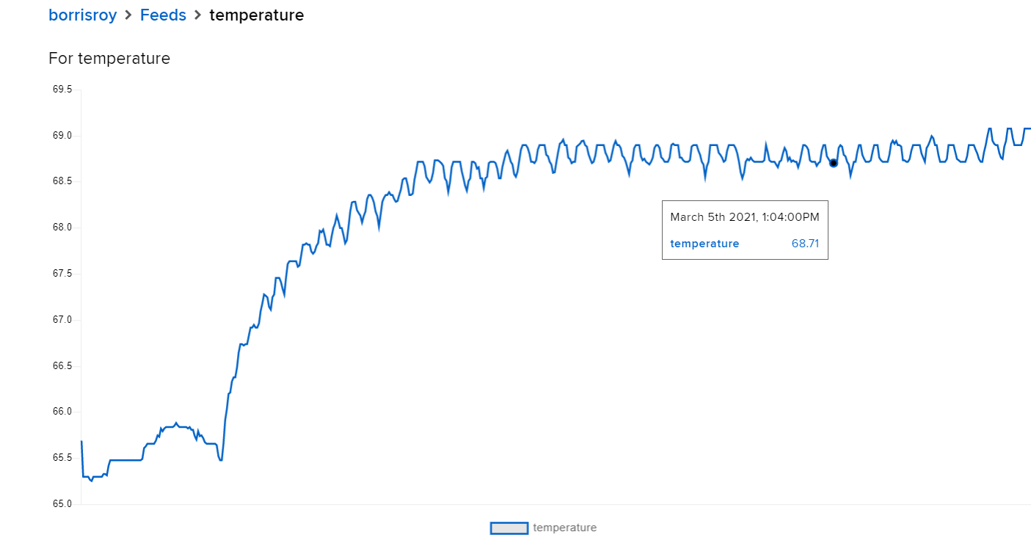

EXPERIMENT 7(Successful results)
PICTURE OF MY DASHBOARD WITH TOGGLE SWITCH
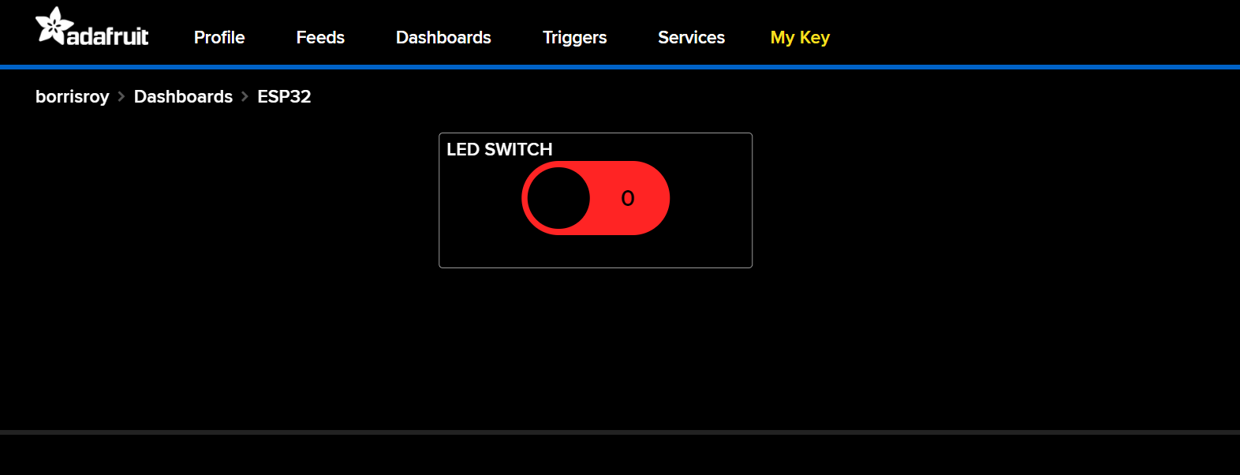

FEED IMAGE (Named it “Photocell”, flat at value 4095 when off and the vertical slopes are when switch is on)
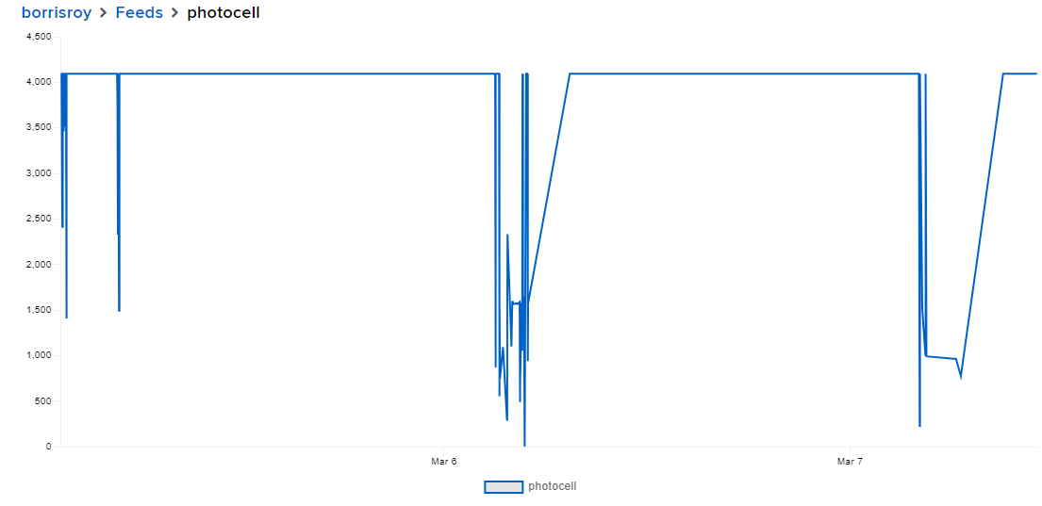
EXPERIMENT 7 CODE (Code explanation in the comments).
#include "WiFi.h"
#include "AdafruitIO_WiFi.h"
#include <AdafruitIO.h>
#include <AdafruitIO_Dashboard.h>
#include <AdafruitIO_Data.h>
#include <AdafruitIO_Definitions.h>
#include <AdafruitIO_Ethernet.h>
#include <AdafruitIO_Feed.h>
#include <AdafruitIO_Group.h>
#include <AdafruitIO_MQTT.h>
#include <AdafruitIO_Time.h>
#include <AdafruitIO_WiFi.h>
//WiFi Configuration
#define WIFI_SSID "Brookes WiFi"
#define WIFI_PASS "HelloBrookes"
//Adafruit IO Configuration
#define IO_USERNAME "borrisroy"
#define IO_KEY "aio_kVTJ62xeEAmRUhHrseKgqb8gvbpF"
AdafruitIO_WiFi io(IO_USERNAME, IO_KEY, WIFI_SSID, WIFI_PASS);
//set up of the photocell feed
AdafruitIO_Feed *photocell = io.feed("photocell");
const int ledPin = 12;//LED pin
const int cellPin = 32;//Photocell pin
//Photocell State
int current = 0;
int last = -1;
void setup() {
pinMode(ledPin, OUTPUT);//LED pin set to OUTPUT
//take single reading from sensor and store it in variable current
current = analogRead(cellPin);
//Start serial connection
Serial.begin(115200);
//wait for serial monitor to open
while(! Serial);
//connect to io.adafruit.com
Serial.print("Connecting to Adafruit IO");
io.connect();
//message handler for "photocell feed"
//using handleMessage function called
//whenever a message is received from adafruit io.
photocell->onMessage(handleMessage);
//Wait for a connection
while(io.status() < AIO_CONNECTED);
//receive the photocell feed.
photocell->get();
}
//function called whenever a 'digital' feed message is
//received from Adafruit IO. it was attached to in the setup() function.
void handleMessage(AdafruitIO_Data *data){
Serial.print("received <- ");
//using data->toPinLevel() function to convert
//incoming data to either LOW or HIGH
if(data->toPinLevel()== HIGH)
Serial.println("HIGH");
else
Serial.println("LOW");
//Write the current state to the led
digitalWrite(ledPin, data->toPinLevel());
}
void loop() {
//io.run required for all sketches
//always be present at the top of the loop
//function. it keeps client connected to
//io.adafruit.com, and processes any incoming data.
io.run();
//get current state of the photocell
current = analogRead(cellPin);
//return if the value hasn't changed
if (current == last)
return;
//save current state of the analog feed
Serial.print("sending ->");
Serial.println(current);
photocell->save(current);
//store last photocell state
last = current;
delay(5000);//wait 5 seconds(5000 milliseconds == 1 seconds)
}

